RESEARCH REPORT ON CHANGING EDUCATION POLICY

SUBMITTED BY- MIHIKA ATTRI
PRO BONO INTERN
3rd YEAR BBA LLB CORPORATE LAW
UNIVERSITY OF PETROLEUM AND ENERGY STUDIES

Table of Contents
Abstract 3
Introduction 4
Research aim and Objective 4
Literature Review 4
Methodology 9
Data analysis and finding 11
Conclusion 20
Recommendation 21
References 22

Abstract
Education policy is an important policy for every nation because it forms a framework of education of a country. Education policy is an important topic to research also. Education policy needs to change from time to time. Due to this reason the researchers have taken the research topic as changing education policy. In this research the importance of education policy is also described. The education policy is important to include all the children in the education system. Education policy is also important to maintain the right of the people of the nation. Education policy is also important to assure that any person or individual of a country can complete their education. The government of India recently changed their education policy. In this research paper the researcher describes the reasons for the change in education policy. In those reasons it is stated that the duration of some degrees has decreased because it is less important in nature.
In this research it has been also discussed that the Government of India makes various policies to educate the people of India. Government also started some vocational training programmes because it helps to enhance skills in the individual who is taking this training. Vocational training also helps the individual to get a job. In this research report it is also discussed that the government has emphasis on research and due to this reason, the government of India includes research projects in each course of study. The government emphasizes the learning of students who are in class 6 to class 8. It is being said that different skills have to be taught to them to enhance their skills. The government also laid more emphasis on NCC training. It has also discussed that MHRD or the Ministry of Human resource and Development also form a department that enables different online courses to the students. This policy also gives emphasis on education of SC, ST, OBC and SEDG as the government provides fellowship programmes to them. The government of India also took care of the educational interest of autistic kids as the government encouraged these students to take part in basic school to university education. This policy also ensures that the education up to 5ht grade and preferably to 8th grade have to be in mother-tongue.
The methodology is used as a primary survey process and sampling is used as a random sampling process. The target group of respondents is government officials. The researcher of this research asks different questions on the effectiveness of this policy. There are 20 government officials chosen randomly as respondents. It is found from this research that majority of responders will think that education policy needs to change from time to time and this education policy implemented successfully in India. It is also found that most of the responders also think that this policy will increase equality in education. Some recommendations also made in this research. The recommendation to insert some clauses to increase the female literacy rate is recommended in this research. It is also recommended that educational institutes may adapt this new and changed educational policy.

Introduction
Every country has certain rules and structure which regulates the country’s education. This policy determines when the exams are conducted, what is the method of study, how the syllabus is made, what is the admission criteria of different colleges, schools and universities and many other things. The education policy of a country mainly sets a standard guideline which is followed by a different school, colleges and universities. This education policy has to be changed from time to time to cope-up with the changes that have happened in the education system in a certain region. The topic of this research paper is Changing Education Policy.

Aim and Objective
The aim of this research is to assess the changes that are made in Indian education policy and effectiveness of these policies in future generations. In order to do this the researcher,has taken two hypotheses such as-
H0 or null hypothesis: New and changed education policy is not effective in nature.
H1 or alternative hypothesis: New and changed education policy effective in nature.
The researcher of this project has set some objective to do this research. The objectives of this research are as follows-
- To identify the changes of this research.
- To access the proper implementation of education policy.
- To access the effectiveness of this education policy.
- To identify the acceptance of this changed education policy.

Literature Review
Importance of education policy
Inclusion of students of different age
Every government made their education policy to include all students or persons in the country because education is a primary service that has to be provided by the government. The people of India are also protected by right to education. According to Eighty-six abatement act, 2002 Article 21-A said that the nation has to provide free education to the children from the age of six to age of sixteen. This is a free and compulsory education policy. On one hand the government can get a measurement or idea about how much the population is getting primary education. Government also can access the regions which need more free and compulsory education.
Forming a discipline
Education policy of a country determines when a student has to be suspended from an institution. Suspension generally happens if a student breaks rules and regulation of an educational institute for repeated time. At first the students are given a warning and after giving a repeated warning the student is finally expelled. It makes the student disciplined in their life as they have to follow the rules and regulation from an early age of life. Sometimes students are not interested in going to go school because of strict rules and regulation and fear of punishment.
Scope for everybody to get education
Many people left their education due many reasons. The Government of India has made certain provisions which help any person at any age to get their education. In order to enable this the government established Indira Gandhi Open University and different free schools.
Reason to change
The education policy of a country determines the steps that have to be completed by the student to get a degree. This policy also determines the duration of a school degree, a college degree and university degree. Education policy also determines the prerequisite of doing research on a certain subject. Certain degree is not necessary to do higher education and that degree may be made unimportant to do. Changes in the duration of a certain school and college depend on the necessity of that particular degree. If the duration of a bachelor degree has increased by the government it means the government gives more emphasis on graduation which gives the student foundation of a subject to a student. The government can decrease the duration of any degree like a Master’s degree if they feel that a particular degree is so important for the students. On one hand students make their foundation strong and understand many topics of a certain subject and on the other hand, students cannot get specialized knowledge on a subject because in a Master degree there is a provision for the students to study on a particular topic that the student likes.
In different educational institutes like school, college and universities different subjects are taught and according to the teaching that they are provided the exams are concluded. The content of these subjects is changed because there is continuous research being done every time. The students of the current batch have to know the topic and subjects that are coming out from that research. For this reason, the syllabus of a subject needs to update time to time. This changing syllabus helps the students to learn new and updated things in one hand. On the other hand, proper awareness of these new subjects is not provided because all the teachers of an educational institute are not updated to teach the students.
The education policy of a country sets the language in which education has to be provided to the students. On one hand this will help the student to make a good hold in a certain language and on the other hand, the students cannot learn that language properly which may be necessary for later days.
Various types of change in educational policies
Although people always realize that important schooling is to mold the future, our nation has also had a big issue. The Indian educational system is struggling with so many problems. We can't ignore the reality that now the Indian government and organizations tried to change the current paradigm of curriculum. There are indeed also some problems that need to be discussed. Learning systems to consider during working periods for vocational training programs is used in school systems or campus systems outside school time and university libraries facilities for Curriculum-equipped alternative training classes, among certain group involvement among learning programs. Emphasis mainly on educational research on every student must study a minimum once course of study, and also be introduced to other more. Sequencing of appropriate skilled trades, including such woodworking, electrical installation, metalworking, farming, pottery, etc., as determined by cities and federal societies throughout classes 6-8.
After 2025, at minimum 50 per cent of students will be introduced to further training across the college and college curriculum. Soon between Classes 6-8, a 10-day handheld duration to support local skilled specialists including craftsmen, landscapers, carvers, photographers, etc.
Equal training programs for children to prepare advanced mathematics during Classes 6-12, which include public holidays. NIOS to build good performance for Indian gesture recognition subsystems. NIOS can create better quality Indian Sign language learning guides including certain essential aspects utilizing Indian different languages.
Kendriya Vidyalaya’s as well as other elementary schools across the nation will be connected to pre - kindergarten divisions providing at minimum a first-year important childcare treatment as well as schooling, especially in depressed communities.
In primary and state education under the defense ministry, NCC sections individual states increasingly promote the establishment of NCC wings in their supplementary and private campuses, such as those based in aboriginal controlled territories, underneath the jurisdiction of the department of Defence. Easy sites to ride in JNV include unrestricted seating facilities built-in line with the Jawahar Navodaya Vidyalaya standards especially for children with financial disadvantages. Specialized Multimedia as well as educational technology network.
Throughout the MHRD, a specialized division would be established to orchestrate the users of innovative technology, electronic information and development resources to meet the online education requirements of either university including broader educational qualifications. A systematic series of guidelines to encourage online schooling in the light of a significant spike in outbreaks. To maintain a level of readiness for alternate forms of qualitative communication anytime and every time conventional and with-person instructional approaches are not practicable have also been discussed.
Wide Fellowship platform to be extended for SC, ST, OBC, SEDG learners will be attempting to encourage the quality of SC, ST, OBC and other SEDG candidates. The accredited educational Platform will be extended to help, cultivate and monitor the success of scholarship-receiving learners. Personal HEIs would be allowed to sell their complimentary ships as well as opportunities in increasing quantities. In conjunction with NCERT the NCTE will devise a fresh and systematic education system for teacher training, NCFTE 2021. By 2030, a 4-year comprehensive B.Ed. would be the required teaching certificate level. Strong measures towards the uniform under-standard new educational center. HECI-Traditional tertiary educational administrative agency states that India's advanced educational Commission (HECI) would be setting life as a normal overall higher education entity, except professional and surgical training. HECI will provide four separate sectors-National Regulatory Council for postsecondary education (NHERC) for oversight, National Council for Education (GEC) for normalization.
Diverse legal guidelines for autistic kids are included. Students with disabilities will be encouraged to engage entirely in the standard school phase throughout basic to university education, with help through teachers with border-disability instruction, community centers, housing, communication systems, suitable resources as well as other community services adapted to specific needs.
The preference of nations, territories, and schools would be the third-language studied by adolescents, as soon as that average three of the four linguistics are indigenous to India. Local community will become the guidance tool anytime practicable, the mode of learning shall be the native languages / native language / neighborhood communication / national dialect till at minimum grade six, but ideally again till eighth grade well beyond. No hurling source distinction for learners.
Learners would be granted greater versatility and selection of programmes to learn, especially in elementary level-including courses in classroom instruction, the art projects and practical training. No strong distinction may occur amongst curricular, extracurricular, or co-curricular, among media, humanities, and sciences, or amongst vocational. In terms of quality and performance, sciences, and arithmetic, topics such as inclusive classrooms, the forms of art and technical training may be integrated into the education system. Several of the 4 phases of primary education can suggest switching to a season or some other method enabling smaller components to be included. Reflective practice as pedagogical knowledge may involve hands-on instruction, art history-integrated and sport-integrated curriculum, teaching methods, and many others. Instructional sales will move to training as well as schooling dependent on expertise.
The prescribed material would concentrate on core topics, theories, implementations and logical- reasoning methods. Educating as well as studying in a more engaging way.
The scope of the program will be condensed to its key basic elements for each topic which will allow for rational reflection and also more systematic, investigation-based, scientific breakthrough-based, debate-based, including experiential practice. Student’s diet and wellbeing (which includes emotional wellness) is treated by nutritious nutrition and daily wellness checks, and insurance certificates are provided to track as much. The Ministry of Human Resource Development (MHRD) would establish the national Project on Fundamental educational achievement on the target. Through this period, committees can often establish other feasible data for classification templates like-annual / summer session / customizable exam preparation; providing all topics at multiple categories starting with arithmetic; two sections examinations or analytical form including qualitative form. Professors may earn a complete 360-degree interactive progress report, which could tell not just regarding the grades they have received in classes, and moreover regarding the talents as well as other relevant aspects.

Methodology
Definition of methodology
Methodology of a research is the data collection process by which the survey is conducted. The methodology reveals not only the process of the data collection but also the processing of the data. The process is important and this process is needed for the research. Data collection is the core of methodology and it can be of two types, primary survey and secondary survey. The primary survey is based on the primary data collection which is collected by the researcher and the secondary data collection is based upon the secondary data that are newspaper articles, journals and other such publications. The primary data collection process can be divided into two types, qualitative and quantitative. In case of quantitative data collection, the samples are chosen randomly and they are given some questions to answer in mcq style. The qualitative data collection method is based upon personal interviews and comprises long and elaborated answers. In the given scenario, the primary survey will be conducted with a quantitative method.
Methodology of the given research
The data collection of the given research process should be a primary survey and the survey should be based upon simple random sampling. The methodology will help to find the reason behind the changing of educational policy. This research topic is a sensitive issue and according to various countries in the world, the educational policy is important for the methodology. Government officials will be chosen for the survey and they will be asked some questions about the change in educational policy. The educational policy is different in case of different countries and each country has their own policies and own methods for the change in the education and the progressive educational systems are important for the countries in the modern world. The change in educational policy is important for the countries and the students of different subjects can be benefited from it. The methodology will be applied for the research that will be upon the government officials who are engaged in the educational policy of various states. In this research, the change in education policy of India will be analysed through a primary quantitative survey of 20 government officials chosen randomly. The random samples will reveal the changing educational policy of the country and the newest policies that are being taken by the Central government in the country. If the policies are properly applied, then the country can prosper. The primary quantitative survey provides the data which can be statistically presented with the help of various statistical tools such as the type of curve, correlation and regression and central tendency. These are important and the data that the survey produces will show the future of the changed policy in the educational sector. The result will also show how the change in the educational sector will affect the students and the job sector in India along with the diversity policy of the education in India. It is important that the research take place as the country is still counted as a third world country and the country needs a reformation in the educational system. The research will show the prospects of the educational reform of the country and the country needs that reformation. The reformation of the country is important for the job seekers as well.
The data collection can be done easily as it is a qualitative data collection method and it will only take 10-15 minutes to answer all the questions as the questions are in multiple choice questions format. The data collected will be processed by statistical tools and the result that comes out will be the result of the research. The research is important and the process is important for the researcher. The research will be conducted only after getting the expressed consent from the sample people and the data will be collected on the basis of the honest answers that the people who are taken as the sample. The expressed consent is needed to do the research so that the people cannot deny the research and provide the honest answers while doing the research. The Answers must be honest and not biased, therefore, the government officials who will be taken as samples will be chosen randomly and from different states of India. This measure will be taken as choosing the sample from one state or one sector can make the result biased. That is not expected at all therefore the sample will be taken from different sectors and different states. That will make the result diverse and as the sample people are government officials, the proper reason for the change and the expected result of the change will be revealed. The primary research will reveal the data that are important for policy-making. The research will also reveal the data that whether the policy needs to be reformed or not. The reformed data are important and the country is needed to maintain changes for the education system of the country.
Ethics in data collection
During the research and data collection process, all the ethics for a research will be followed and the name and designations of the government officials will not be published. The research will completely keep their confidentiality so that the people do not get into any problematic situation for being a sample. The data that will be collected will not be used in any other cases except this research. This is the ethics that will be followed by the researcher during this research. The ethics are important for any research and this research will follow the ethics as well. The ethics should be maintained to keep the confidentiality of the sample people and to reveal only the data that have been collected from the survey. The survey needs to be ethical and properly done.

Data analysis and finding
The data analysis is important for the change in educational policy and the educational policy is very important for the modern countries as education is the base of every prospect in life. The research has been done upon 20 government officials from different countries chosen randomly for the research and they will provide the data of the survey. There are 10 questions that they have answered with five options in each question. The questions will reveal the data that will be processed by the statistical tools. The data that are processed will be the final result of the research and on the basis of that data the final result will be published. The primary data that are collected in the survey will not be used in any other form and the ethics have been properly maintained.
Q1. How far do you agree that the educational policy needs to change from time to time?
Options | Responses | Total Number of Respondents | Percentage of response
Highly agree | 15 | 20 | 75.00%
Agree | 5 | 20 | 25.00%
Neutral | 0 | 20 | 0.00%
Disagree | 0 | 20 | 0.00%
Highly disagree | 0 | 20 | 0.00%
Table 1: Need of change in education policy
(Source: As done by the researcher)

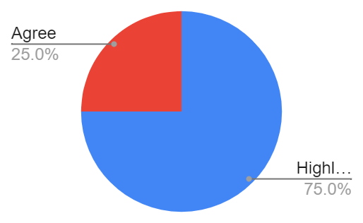
Figure 1: Need of change in education policy
(Source: As done by the researcher)
This question shows that most of the people chosen as the sample think that the change is needed from time to time. 75% people highly agree to the point that the change in the educational policy is needed. 25% of people agree with the fact and 0% of people disagree with it.
Q2. How far do you agree that the change in educational policy can be successfully applied?
Options | Responses | Total Number of Respondents | Percentage of response
Highly agree | 10 | 20 | 50.00%
Agree | 5 | 20 | 25.00%
Neutral | 2 | 20 | 10.00%
Disagree | 3 | 20 | 15.00%
Highly disagree | 0 | 20 | 0.00%
Table 2: Successful application
(Source: As done by the researcher)
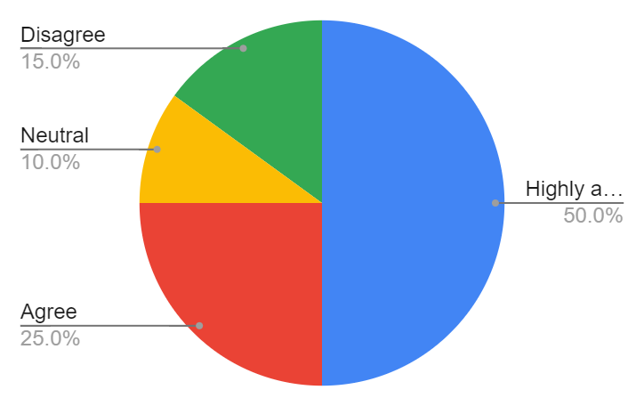
Figure 2: Successful application
(Source: As done by the researcher)
10 people out of 20 people think that the change in educational policy can be successfully applied and they highly agree with it. 25%, 10% and 15% people agree, neutral and disagree with the point respectively.
Q3. How far do you agree that the change in educational policy needs higher degrees?
Options | Responses | Total Number of Respondents | Percentage of response
Highly agree | 7 | 20 | 35.00%
Agree | 5 | 20 | 25.00%
Neutral | 2 | 20 | 10.00%
Disagree | 3 | 20 | 15.00%
Highly disagree | 3 | 20 | 15.00%
Table 3: Higher degree
(Source: As done by the researcher)
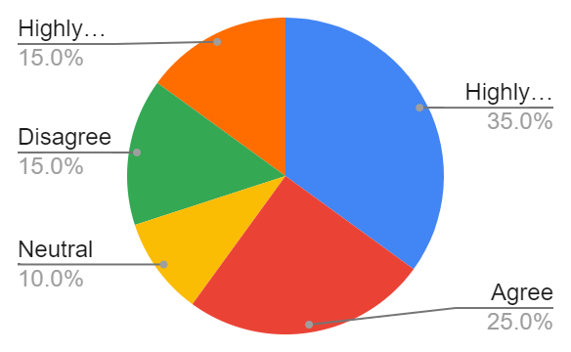
Figure 3: Higher degree
(Source: As done by the researcher)
In this question, 35% of people highly agree with the point that a higher degree is needed for the change in educational policy. 25% of people agree with the point and 10% of people are neutral. 15% of people disagree and 15% of people strongly disagree with the point.
Q4. How far do you agree that the change in educational policy will help the students?
Options | Responses | Total Number of Respondents | Percentage of response
Highly agree | 12 | 20 | 60.00%
Agree | 6 | 20 | 30.00%
Neutral | 2 | 20 | 10.00%
Disagree | 0 | 20 | 0.00%
Highly disagree | 0 | 20 | 0.00%
Table 4: Help for the students
(Source: As done by the researcher)
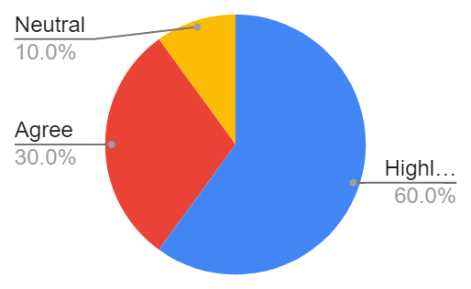
Figure 4: Help for the students
(Source: As done by the researcher)
In this question 12 people out of 20 people strongly agree that the change in educational policy will help the students and 6 people agree with the point. Only 2 people are neutral and no one disagrees with the point.
Q5. How far do you agree that the change in educational policy will be accepted by common people?
Options | Responses | Total Number of Respondents | Percentage of response
Highly agree | 9 | 20 | 45.00%
Agree | 4 | 20 | 20.00%
Neutral | 2 | 20 | 10.00%
Disagree | 3 | 20 | 15.00%
Highly disagree | 2 | 20 | 10.00%
Table 5: Acceptance of common people
(Source: As done by the researcher)
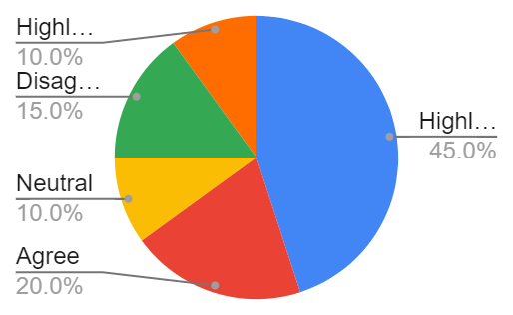
Figure 5: Acceptance of common people
(Source: As done by the researcher)
In this question 9 people out of 20 people highly agree with the point and 4 people agree. 2 persons are neutral about it and 3 and 2 persons disagree and strongly disagree respectively.
Q6. How far do you agree that the change in educational policy will affect the future generation?
Options | Responses | Total Number of Respondents | Percentage of response
Highly agree | 8 | 20 | 40.00%
Agree | 7 | 20 | 35.00%
Neutral | 2 | 20 | 10.00%
Disagree | 2 | 20 | 10.00%
Highly disagree | 1 | 20 | 5.00%
Table 6: Effect on future generation
(Source: As done by the researcher)
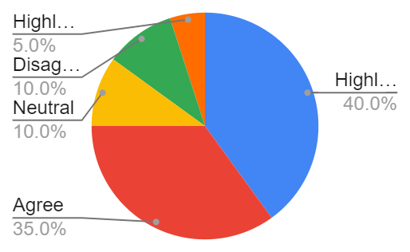

Figure 6: Effect on future generation
(Source: As done by the researcher)
In this question, 40% of people strongly agree with the point that the changes in the educational policy will affect the future generation. 7, 2, 2 and 1 person agree, neutral, disagree and strongly disagree with the point respectively.
Q7. How far do you agree that the change in educational policy will help the state boards?
Options | Responses | Total Number of Respondents | Percentage of response
Highly agree | 6 | 20 | 30.00%
Agree | 4 | 20 | 20.00%
Neutral | 3 | 20 | 15.00%
Disagree | 4 | 20 | 20.00%
Highly disagree | 3 | 20 | 15.00%
Table 7: State boards
(Source: As done by the researcher)
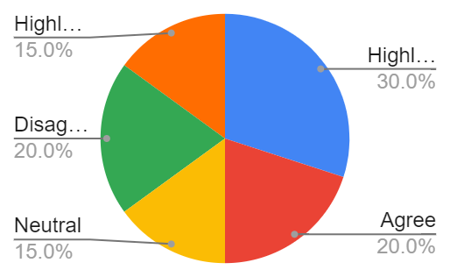
Figure 7: State boards
(Source: As done by the researcher)
In this question a mixed result has come. 6 people out of 20 people think that the change in educational policy will help the state boards. 4 people agree with it, 3 people are neutral about it, 4 and 3 people disagree and strongly disagree with the point.

Q8. How far do you agree that the change in educational policy will bring diversity in education?
Options | Responses | Total Number of Respondents | Percentage of response
Highly agree | 6 | 20 | 30.00%
Agree | 7 | 20 | 35.00%
Neutral | 1 | 20 | 5.00%
Disagree | 3 | 20 | 15.00%
Highly disagree | 3 | 20 | 15.00%
Table 8: Diversity in education
(Source: As done by the researcher)
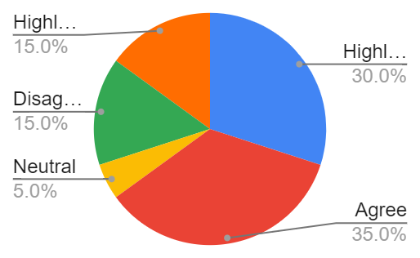
Figure 8: Diversity in education
(Source: As done by the researcher)
In this question, the answers are mixed. 30% and 35% of people think that the change in educational policy will bring diversity in the educational system. 5% of people are neutral. 15% and 15% of people disagree and strongly disagree respectively.
Q9. How far do you agree that the change in educational policy will increase the quality of education?
Options | Responses | Total Number of Respondents | Percentage of response
Highly agree | 10 | 20 | 30.00%
Agree | 7 | 20 | 35.00%
Neutral | 0 | 20 | 5.00%
Disagree | 3 | 20 | 15.00%
Highly disagree | 0 | 20 | 15.00%
Table 9: Quality of education
(Source: As done by the researcher)
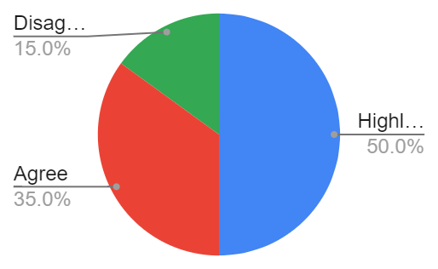
Figure 9: Quality of education
(Source: As done by the researcher)
In this question, 10 out of 20 people strongly agree that the change in the educational policy will increase the quality of the education. 35% of people that are 7 people agree with the topic and 3 persons disagree with it.
Q10. How far do you agree that the change in educational policy will help people to get jobs?
Options | Responses | Total Number of Respondents | Percentage of response
Highly agree | 7 | 20 | 35.00%
Agree | 9 | 20 | 45.00%
Neutral | 4 | 20 | 20.00%
Disagree | 0 | 20 | 0.00%
Highly disagree | 0 | 20 | 0.00%
Table 10: Chances to get jobs
(Source: As done by the researcher)
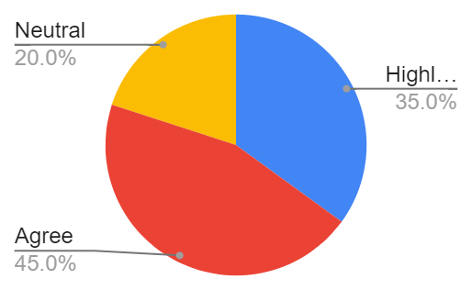
Figure 10: Chances to get jobs
(Source: As done by the researcher)
35%, 45% and 20% of people taken for the sample strongly agree, agree and neutral on the fact that the chances of getting a job will get higher with the change of the educational policy.

Conclusion
It can be concluded from this report that the change of the policy of education in India is important as the country is a progressive country and for the betterment of the education system of the country, the changes are needed. The objective of this report is to identify the changes that are needed for the country’s educational system and the policies that are going to be taken to fulfill those needs in the educational system. The policies such as the reformation of the framework of the educational system are a part of this. The reformation of the framework also includes the unification of the schooling systems. The schools will be teaching the same syllabus and in English language with their native language which will be important for the students in various states. The native language is important and that can be taken as the second language. The lower caste people such as the Scheduled Castes and Scheduled Tribes and the other backward classes will get more chances to complete their education. The Indian schooling system used to follow the British schooling system however, with the new changes the Indian schooling system has created some unique policies. In the data survey most of the people think that the new policies will help the students to learn their subject properly and will provide them fair chances to get jobs. The educational reform may bring diversity in the educational system and the educational system is important for the country. The literacy rate is quite low in the country and the reformation of the framework will increase the literacy rate according to the government.

Recommendation- A viable solution to loopholes in Education Policy
The literacy rate of India is 74 percent and among them female literacy rate is 65 percent and male literacy rate is 80 percent. For this reason, the government has to include some clauses in their educational policy which increase the female literacy rate at a considerable level because females played an important role in child education. It is also recommended that the government has to open more schools in various parts of the country. It is also recommended that educational institutes may adopt this education policy as this education policy helps to reduce inequality in the education system and help to build a stronghold in the basics of a subject and this policy gives emphasis on vocational training.

References
- Avasthi, A., The Prospects of Industrial Democracy in the Context of the Proposed New Educational Policy in India. The State, Trade Unions and Self-Management, p.315.

- Bhushan, S. and Mathew, A., 2019. Quality and Excellence in Higher Education and Metamorphosis: Changing Notions in Educational Discourses in India. Higher Education for the Future, 6(1), pp.52-69.

- Chakraborty, A., 2020. Changing Public–Private Mix in School Education and Its Implications for Policy. In Universal Secondary Education in India (pp. 101-112). Springer, Singapore.

- Dewan, H., 2018. Evolution of education policy in India and its impact on government initiative. Learning Curve, (30), pp.08-11.

- Koundinya, D.S., 2019. Book Review: Internationalization of Higher Education in India.

- Maruthavanan, M., 2020. A Study on the Awareness on New Education Policy (2019) among the Secondary School Teachers in Madurai District. Shanlax International Journal of Education, 8(3), pp.67-71.

- Mehta, S.B.A., 2019. CHANGING PATTERNS OF EDUCATION SYSTEM IN INDIA. Journal Current Science, 20(4).

- PADDER, D.M.U.J., Role of Education Policies in Economic Development of India.
Rao, K.V., 2020. A Roadmap for Higher Education Policy Making In India. Evincepub publishing.

- Vicente-Sáez, R. and Martínez-Fuentes, C., 2018. Open Science now: A systematic literature review for an integrated definition. Journal of business research, 88, pp.428-436.
ABOUT THE AUTHOR
Mihika Attri is a Third Year Law Student of BBA LLB (Hons.), specialization in Corporate Law at University of Petroleum and Energy Studies, Dehradun. She is currently an intern in Pro Bono India. She takes avid interest in Corporate and Criminal Law. She has been a part of many committees in her college and has been a perfect blend of academic as well as co-curricular activities.

Rao, K.V., 2020. A Roadmap for Higher Education Policy Making In India. Evincepub publishing
Avasthi, A., The Prospects of Industrial Democracy in the Context of the Proposed New Educational Policy in India. The State, Trade Unions and Self-Management, p.315.
PADDER, D.M.U.J., Role of Education Policies in Economic Development of India.
Dewan, H., 2018. Evolution of education policy in India and its impact on government initiative. Learning Curve, (30), pp.08-11.
Maruthavanan, M., 2020. A Study on the Awareness on New Education Policy (2019) among the Secondary School Teachers in Madurai District. Shanlax International Journal of Education, 8(3), pp.67-71.
Koundinya, D.S., 2019. Book Review: Internationalization of Higher Education in India.
Vicente-Sáez, R. and Martínez-Fuentes, C., 2018. Open Science now: A systematic literature review for an integrated definition. Journal of business research, 88, pp.428-436.
Bhushan, S. and Mathew, A., 2019. Quality and Excellence in Higher Education and Metamorphosis: Changing Notions in Educational Discourses in India. Higher Education for the Future, 6(1), pp.52-69.
Chakraborty, A., 2020. Changing Public–Private Mix in School Education and Its Implications for Policy. In Universal Secondary Education in India (pp. 101-112). Springer, Singapore.
Mehta, S.B.A., 2019. CHANGING PATTERNS OF EDUCATION SYSTEM IN INDIA. Journal Current Science, 20(4).

